Resetting the Vision set up password

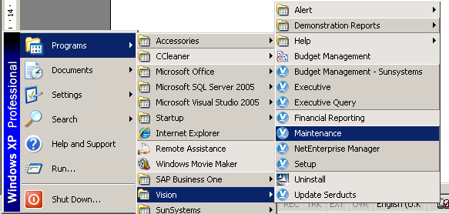

Click Start -> Programs -> Vision -> Maintenance

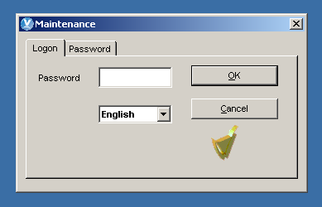

Click Ok

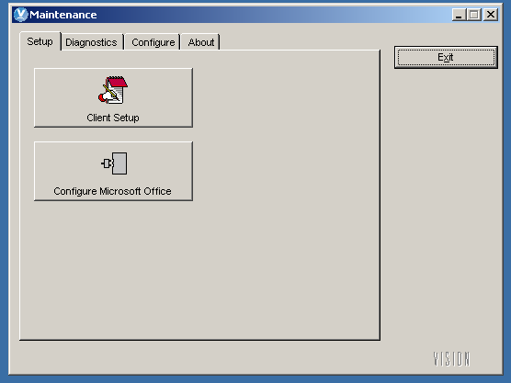

Click the Configure tab

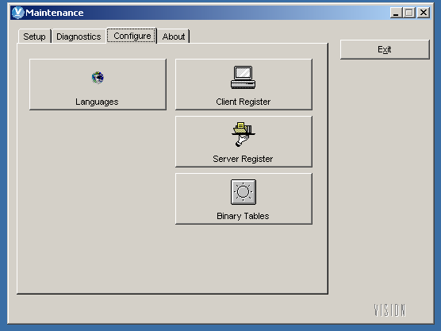

Click Server Register

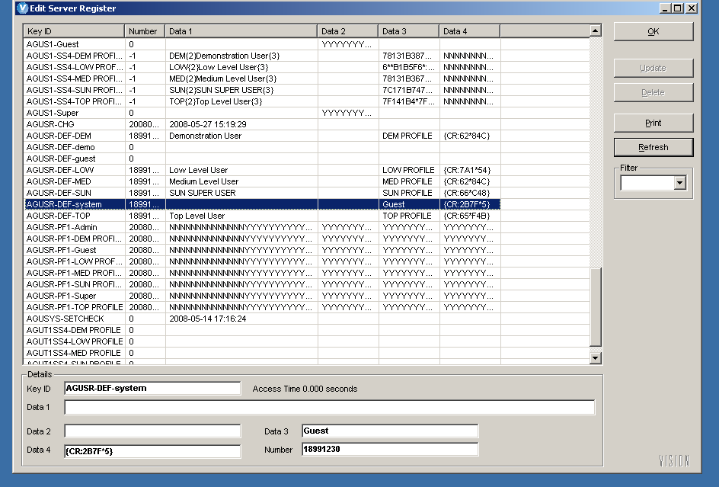
Locate AGUSR-DEF-system key ID.

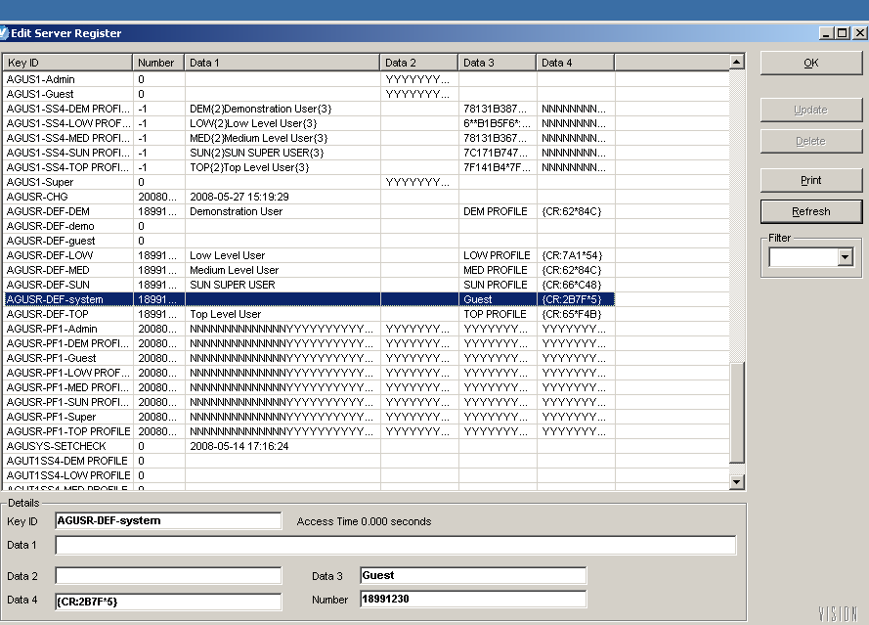

Clear Data2 and Data4 fields which hold the password, then press Ctrl (hold down), Alt (hold down) and click the right hand mouse button with the point above the VISION icon in the bottom right corner. Once you have done this the Update button will become active.
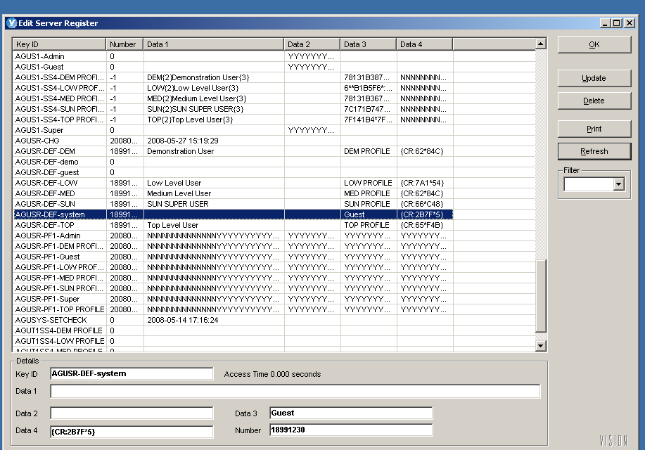

Click the update button and then click Ok. Log onto the Vision set up system

